input.doc



ANIMAL PRODUCTION SYSTEMS SAMPLE EXAMINATION

Section 7 of the New WACE Manual: General Information 2006–2009 outlines the policy on WACE examinations.

Further information about the WACE Examinations policy can be accessed from the Curriculum Council website at http://newwace.curriculum.wa.edu.au/pages/about_wace_manual.asp.

The purpose for providing a sample examination is to provide teachers with an example of how the course will be examined. Further finetuning will be made to this sample in 2007 by the examination panel following consultation with teachers, measurement specialists and advice from the Assessment, Review and Moderation (ARM) panel.




Sample Examination

Question/Answer Booklet

ANIMAL PRODUCTION
Please place your student identification label in this box
SYSTEMS

Student Number: In figures

In words

Time allowed for this paper
Reading/planning time before commencing work: Ten minutes
Working time for paper: Three hours

Material required/recommended for this paper

To be provided by the supervisor
This Question/Answer Booklet

To be provided by the candidate
Standard items: Pens, pencils, eraser or correction fluid, highlighter, ruler, printed English language dictionary and/or bilingual dictionary (non electronic and not a thesaurus)

Special Items: Calculators satisfying the conditions set by the Curriculum Council for this course.

Important note to candidates
No other items may be taken into the examination room. It is your responsibility to ensure that you do not have any unauthorised notes or other items of a non-personal nature in the examination room. If you have any unauthorised material with you, hand it to the supervisor before reading any further.
Structure of this paper

Section | Outcomes | Suggested working time | Number of questions available | Number of questions to be attempted
ONE:  Short response | 1,2,3 and 4 | 140 mins | 8 | 8
TWO:  Extended response | 2 and 3 | 40 mins | 2 | 1

Instructions to candidates

- The rules for the conduct of Curriculum Council examinations are detailed in the Student Information Handbook. Sitting this examination implies that you agree to abide by these rules.

- Answer all questions by writing your answers in this booklet in the spaces provided.

- You must be careful to confine your responses to the specific questions asked and to follow any instructions that are specific to a particular question.

- Spare answer pages may be found at the end of this booklet. If you need to use them, indicate in the original answer space where the answer is continued (i.e. give the page number).

THIS PAGE HAS BEEN LEFT BLANK INTENTIONALLY

SECTION ONE: Short response

This section has EIGHT questions. Attempt ALL questions.

Allow approximately 140 minutes for this section [134 marks].

The following maps refer to weather conditions.

Question 1
(Board of Studies New South Wales, 2005)

Answer the following questions by referring to the maps on page 4.

- What does the symbol indicate on the weather map?
[1 mark]

- Identify the type of pressure system at point X and at point Y located on Map A.
[2 marks]

- In which direction will winds travel around pressure systems X?
[1 mark]

- Using information from maps A and B, outline and predict the changes in weather conditions at point Z between 10 pm on 2 August and 12 noon on 3 August 2004, and identify a possible consequence of this forecast on an extensive animal production enterprise.
[2 marks]

Question 2
Name ONE farm product you have studied.

Name of farm product:
(Board of Studies New South Wales, 2001)

- Identify ONE criterion for assessing the quality of the product.
[1 mark]

- Describe TWO actions a farmer may take to maximise the quality of the product before it leaves the farm.
[2 marks]

- Explain, using a specific example, how agencies or organisations may contribute to the marketing of the product.
[2 marks]

- Discuss the advantages and disadvantages of the impact of one aspect of scientific research, on the production process for the product.
[5 marks]

Question 3
(Board of Studies New South Wales, 2001)

The graph below shows Australian commodity prices for three groups (wool, beef and wheat) relative to 1980.
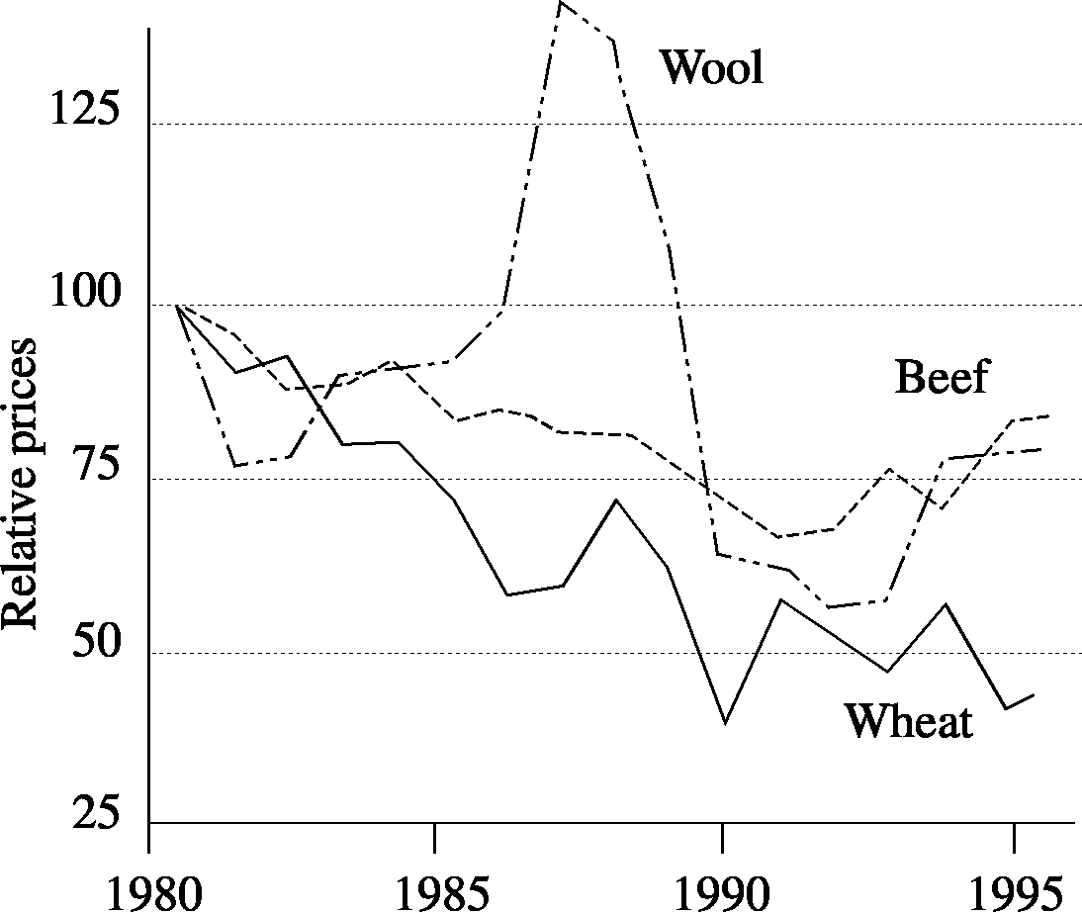

Fig. 1: Australian commodity prices relative to 1980

- What is the main trend over time for prices received by farmers in all three commodity groups?
[3 marks]

- Describe TWO possible changes to farming practices if this trend continues.
[2 marks]

Question 4.
- Identify and describe a significant characteristic in a breeding system for an animal production system you have studied.
(Board of Studies New South Wales, 2001) [3 marks]

- Describe an objective measurement used to monitor that characteristic.
(Board of Studies New South Wales, 2001) [5 marks]

- Explain how a producer can effectively meet the stated characteristic in the breeding program.
[4 marks]

Question 5
- What is meant by a Feed Conversion Ratio (FCR)?
[1 mark]

- Why do ruminant animals have a less efficient feed conversation ratio than mono-gastric animals?
(Board of Studies New South Wales, 2001) [2 marks]

Question 6
The oestrous cycle:
Complete the following sentences using the words provided.
[8 marks]

Word list
Corpus luteum, progesterone, Follicle stimulating hormone (FSH), Luetenising hormone (LH), pituitary gland, follicle, oestrogen,

_________________is released from the _________________and stimulates a _________________to develop in the ovary. Once the follicle is developed, the ovary releases the hormone _________________which stops FSH production. The pituitary gland releases the hormone _________________which makes ovulation occur. After ovulation the follicle degenerates and becomes the._________________ which releases_________________. This stops the oestrous cycle and prepares the body for pregnancy. If pregnancy does not occur the uterus produces prostaglandins to reduce the size of the corpus luteum and progesterone levels. This stimulates the _________________ to release FSH and the cycle starts again.
(Clark, c2004)

THIS PAGE HAS BEEN LEFT BLANK INTENTIONALLY
Question 7 refers to the information below

Table 1: Beef cattle breeding herd records, 2006

Cow No. | Breed * | Age (yrs) | Calf No. | Sex ** | Date of birth  (DoB) | Birth Weight (kgs) | Weaning weight on 11/9/06 (kgs) | Age at 11/9 (days)  (DoB-11/9) | Growth Rate (kgs/day) | Corrected 200 day weight  (kgs) | Rank | Comments
607 | MG-A | 3 | 916 | H | 2/4/06 | 23 | 90 | 163
108 | A | 4 | 915 | B | 26/3 | 42 | 188 | 170 | 0.85 | 212
A9 | A | 6 | 914 | B | 26/3 | 34 | 173 | 170 | 0.82 | 190
B8 | A | 7 | 913 | S | 26/3 | 30 | 175 | 170 | 0.85 | 200 |  | B8=Fence breaker
40 | A | 6 | 912 | H | 23/3 | 34 | 174 | 173 | 0.81 | 204
35 | A | 13 | 909 | B | 22/3 | 32 | 118 | 174 | 0.49 | 145
802 | SF-MG | 1.5 | 908 | B | 21/3 | 30 | 122 | 175 | 0.53 | 152
U50 | A | 14 | 907 | H | 29/3 | 45 | 126 | 167 | 0.49 | 172
30 | SF | 5 | 906 | H | 31/3 | 66 | 229 | 165 | 0.99 | 274
105 | A | 4 | 905 | S | 29/3 | 50 | 175 | 167 | 0.74 | 205
U52 | A | 12 | - | B | 30/3 | 45 | Died at birth |  |  |  |  | Dystocia
B21 | A | 7 | 904 | S | 31/3 | 66 | 220 | 165 | 0.93 | 252

‘How to calculate calf growth and corrected 200 day weights’

Information needed to calculate:
- Growth Rate (kgs/day) = Weaning Weight (11/9) – Birth weight
Age at 11/9 (days)
Formula:
- Corrected 200 day weight (kgs) =
(Growth Rate x 200) + (Corrections for Sex of calf and Age of cow) + (Calf Birth Weight)

- To compare calves of different ages:
Calculate corrected 200 day weight = Growth Rate x 200 (kg)

- To compare calves of different sex growing at different rates:
Correct the 200 day weight as follows:
- Bulls = (Growth Rate x 200) – 5%( Growth Rate x 200)
- Steers = (Growth Rate x 200)
- Heifers = (Growth Rate x 200) + 5%( Growth Rate x 200)

- To compare calves from different aged cows {have bigger or smaller calves and have higher or lower milk yields}
Correct the 200 day weight as follows:
- 2 yr old cow = (Growth Rate x 200) + 15%( Growth Rate x 200)
- 3 yr old cow = (Growth Rate x 200) + 10%( Growth Rate x 200)
- 4 yr old cow = (Growth Rate x 200) + 5%( Growth Rate x 200)
- 5-9 yr old cow = (Growth Rate x 200) + 0%( Growth Rate x 200)
- 10 yr old cow = (Growth Rate x 200) + 5%( Growth Rate x 200)
- 11 yr old cow = (Growth Rate x 200) + 10%( Growth Rate x 200)
- 12 yr old cow = (Growth Rate x 200) + 15%( Growth Rate x 200)
- Do not forget to add on weight of calf at birth
Question 7
Farmers use a variety of strategies to produce a more marketable product. These include:
- purchasing more animals
- breeding more suitable stock
- improving the health and nutrition of the stock.

Deciding which strategies to use is best informed by reliable data. Table 1 contains data that will help the farmer decide which animals will become next year’s breeding stock.

- Explain how you would collect and record the data shown in Table 1 on page 12.
[5 marks]

- Using data from Table 1, page 12, and the information supplied on ‘How to calculate Calf Growth and Corrected 200 day Weights.’ Calculate the missing data for cow 607 and place the results in the Table on page 12. Show all your workings in the space below.
[2 marks]

- Complete the RANK column in Table 2 on page 12.
Rank in order of weight:
- 1 = heaviest calf and
- 12 = lightest calf
[2 marks]

Using previous data, answer the following justifying your selections:

- Cows to keep as breeders
[14 marks]

- Cows to cull
[10 marks]

- Heifers for the 2007 herd
[2 marks]

- Steers/bulls and heifers for immediate sale
[7 marks]

- Steers/bulls and heifers for feedlot and sale in December/January
[5 marks]

Question 8
Scenario: Refer to data you have analysed in Question 7 to answer this question.

As a regional livestock adviser, the farmer has asked you to evaluate the effectiveness of his/her decisions regarding the 2006/2007 breeders and offspring. He used the same breed of sire for the 2006 and 2007 matings and wonders whether he should do the following for 2008:
- use a different breed or breeds of sire over females.
- purchase some more females to increase his herd size.

By adopting one or both of these strategies, the farmer expects to increase his/her returns on the marketed product.

You are to design a process to specify relevant data needed, and report your findings to enable you to

- carry out the evaluation.
[23 marks]

- make recommendations about potential sires.
[10 marks]

- make recommendations regarding an increase in female breeders.
[10 marks]

SECTION TWO: Extended answer

This section contains TWO questions.

Choose one question and write your answers in the spaces provided.

Allow approximately 40 minutes for this section [28 marks].

Question 1
There are various techniques used to manipulate the oestrous cycle in farm animals.

Identify, explain and evaluate one technique that a farmer may use to manipulate the oestrous cycle in an animal model of your choice.
[28 marks]

OR

Question 2
Chemical Safety Standards are a vital part of animal production.

Identify six main classes of safe veterinary chemicals and explain the importance of adequate labelling for each product. In your response, predict one consequence, in relation to an animal you have studied, if these instructions are not followed.
[28 marks]

END OF PAPER
ACKNOWLEDGEMENTS

Published by the Curriculum Council of Western Australia
27 Walters Drive
OSBORNE PARK WA 6017
SECTION ONE

Question 1: Maps
Bureau of Meteorology. (2004). [Weather maps of Australia: 10 pm 2 August 2004; 4 am 3 August 2004]. Retrieved October, 2006, from Board of Studies New South Wales website: http://www.boardofstudies.nsw.edu.au/hsc_exams/hsc2005exams/pdf_doc/primary_ind_vet_05.pdf.

Parts a–d
Board of Studies New South Wales. (2005). Primary Industries: 2005 Higher School Certificate Examination (p. 21, qs 20a–d). Retrieved October, 2006, from http://www.boardofstudies.nsw.edu.au/hsc_exams/hsc2005exams/pdf_doc/primary_ind_vet_05.pdf.

Question 2: Board of Studies New South Wales. (2001). Agriculture
Paper 1: 2001 Higher School Certificate Examination (p. 2, q. 1). Retrieved October, 2006, from http://www.boardofstudies.nsw.edu.au/hsc_exams/hsc2001exams/pdf_doc/agricult_p1_01.pdf.

Question 3: Board of Studies New South Wales. (2001). 2001 HSC specimen paper: Agriculture (p. 5, q. 2). Retrieved November, 2006, from http://www.boardofstudies.nsw.edu.au/syllabus_hsc/pdf_doc/agriculture_specexam.pdf.

Question 4a–b: Board of Studies New South Wales. (2001). 2001 HSC specimen paper: Agriculture (p. 12, q. 5a). Retrieved November, 2006, from http://www.boardofstudies.nsw.edu.au/syllabus_hsc/pdf_doc/agriculture_specexam.pdf.

Question 5b: Board of Studies New South Wales. (2001). 2001 HSC specimen paper: Agriculture (p. 13, q. 5c). Retrieved November, 2006, from http://www.boardofstudies.nsw.edu.au/syllabus_hsc/pdf_doc/agriculture_specexam.pdf.

Question 6: Clark, A. (c2004). Senior agriculture (Book 1). Clayton South, Vic.: Blake Education.

